INDUSTRIAL TRAINING REPORT

ON

“RAILWAY COMMUNICATION SYSTEM”

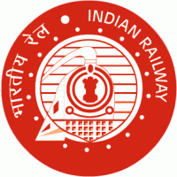

UNDER THE SUPERVISION OF-

MISS PAYAL SARDAR (Junior Engineer)

MR. R.P. HALDAR (Sr. Section Engineer)

MR. TUSHAR PANDA (Sr. Section Engineer)

Submitted By

SATYAPRAKASH RATH (122EI0621)

INTERN( 2nd Year)

COLLEGE-NIT ROURKELA

Preface

Summer Industrial Training are very important for engineering students. This training provides the opportunity to be familiar with the industrial environment. During this training they show and enhance their practical skills and gain practical knowledge and experience for future. This is the best way through which the students can learn the latest technologies being used in the companies.

I **Satyaprakash Rath** have undergo through Summer Training on “**Railway Communication System”** from **“East Coast Railway,Bhubaneswar”.** The training helped me a lot in learning the technologies of this particular field.

Industrial Training was very challenging but as I proceeded things got easier. This Summer Internship Training was an interesting learning experience for me.

ACKNOWLEDGEMENT

I express my sincere thanks to **Miss Payal Sardar** of JE/Telecom Exchange at East Coast Railway (Khurdha Division). It is my pleasure to seek this opportunity to do my project on this subject PRS,UTS and Railnet. At this moment of successful completion of the project, I would like to express my sincere thanks to all those who extended their kind help by spending their precious time in explaining the various intricates of the subject and suggesting the correct approach to me.

I heartly thanks to **Mr.R.P. Haldar** (SSE/Tele/Exchange) and **Mr.Tushar Panda** (SSE/Tele/Exchange) at East Coast Railway(Khurdha division). Under whose guidance I started off with the project. Without whose direction, critical supervision and refreshing encouragement this project would not have been possible.

It is great honour to express respect and gratitude to East Coast Railway, Bhubaneswar, for providing the constant source of motivation and encouragement.

Their support has helped me to complete my project on time.

Satyaprakash Rath

Intern (Khurdha Division)

NIT ROURKELA

WEEKLY DIARY

**Week-1**

ISDN / IP Exchanges, Railnet, FOIS, Control Comm., OFC, SDH &

PDH, Wireless Communication

**Week-2**

PA Systems, CCTV, TIB, CIB, Passenger Reservation System,

Unreserved Ticketing System.

**Week-3**

Block Working Principle, Auto signalling / EI, BAPC / LVCD, Data

Logger, SSI, ELB, RRI.

TABLE OF CONTENTS

* INTRODUCTION OF INDIAN RAILWAY
* RAILNET
* PRS & UTS
* ROUTER
* AUTO SIGNALLING /ELECTRONICS INTERLOCKING(E.I.)
* CONCLUSION

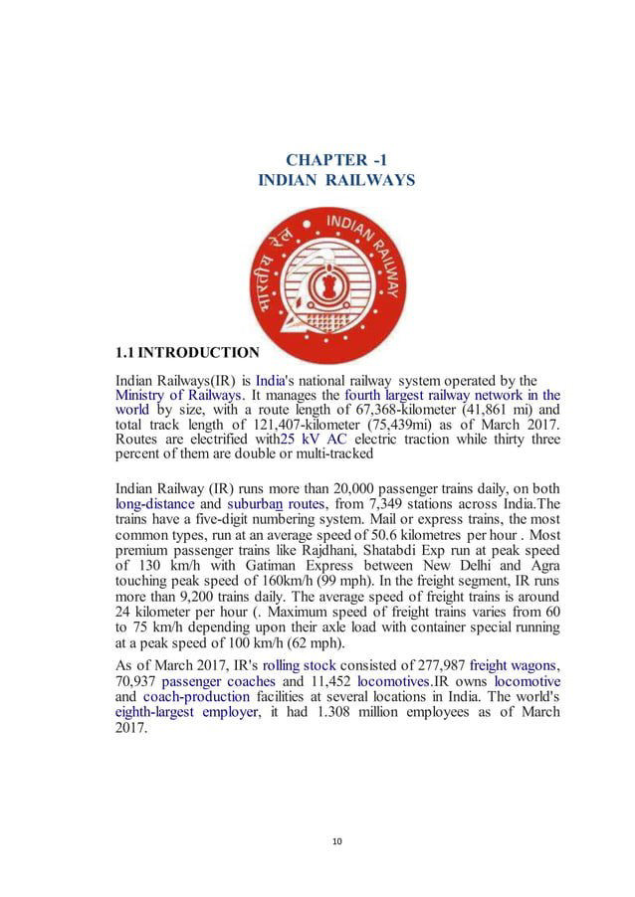

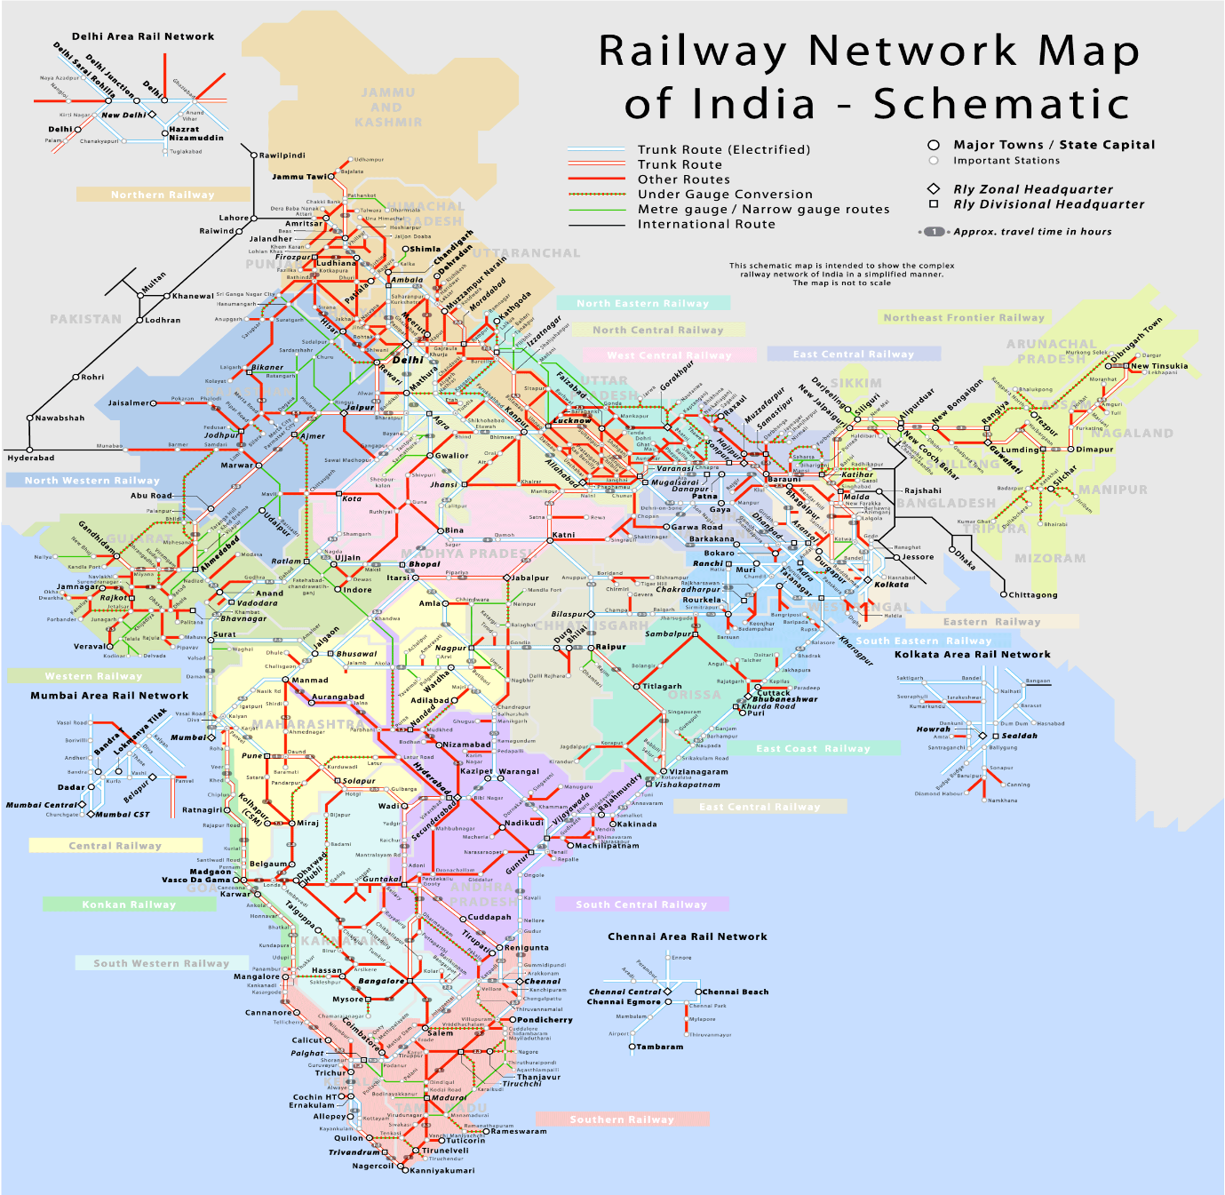

[This Photo](https://www.populationdata.net/cartes/inde-reseau-ferroviaire/) by Unknown Author is licensed under [CC BY-NC](https://creativecommons.org/licenses/by-nc/3.0/)

Fig. 1.1 Showing Rail Network of India

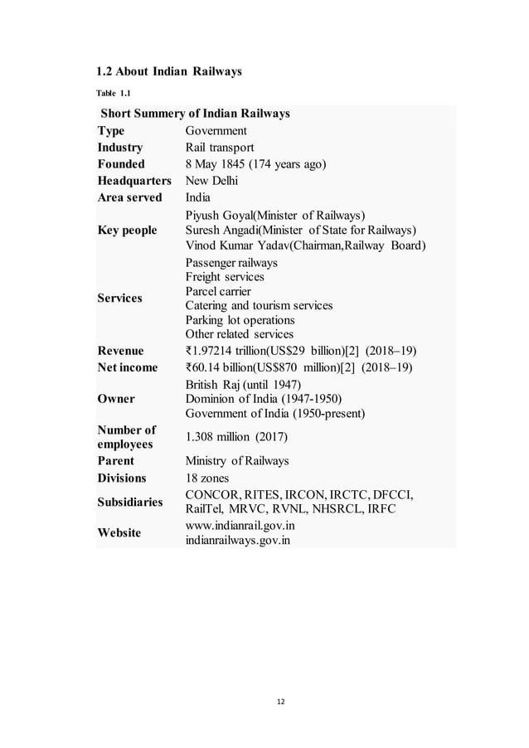

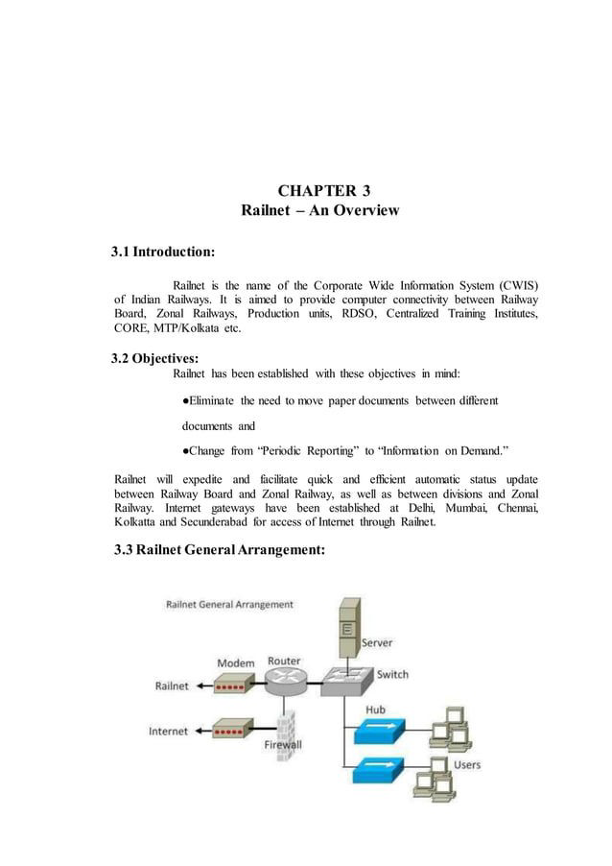

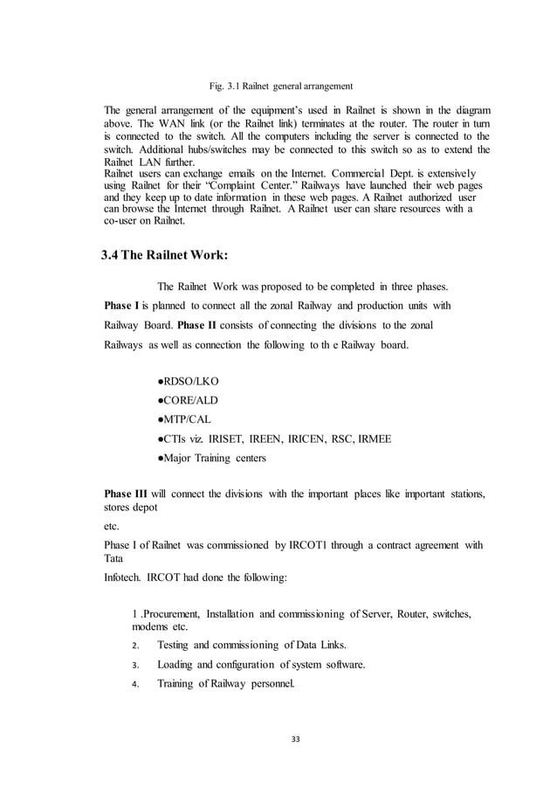

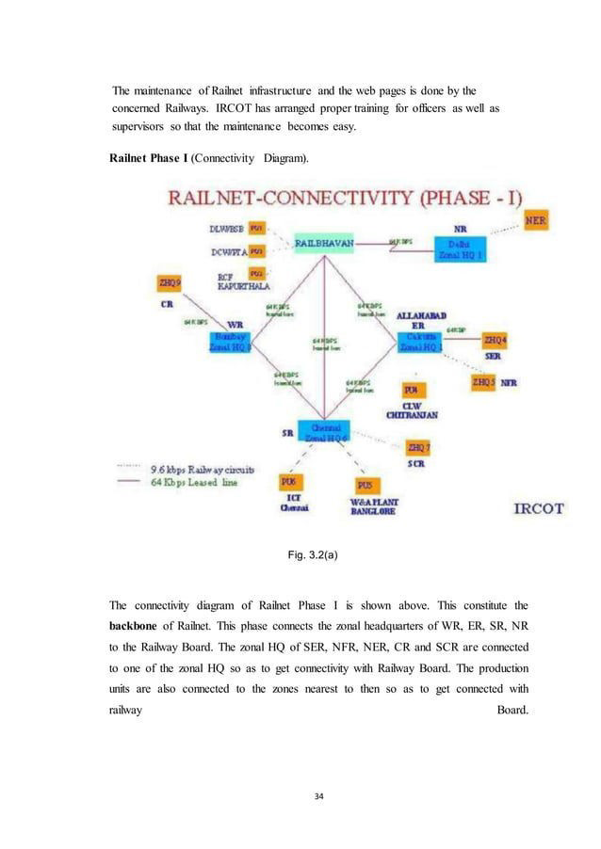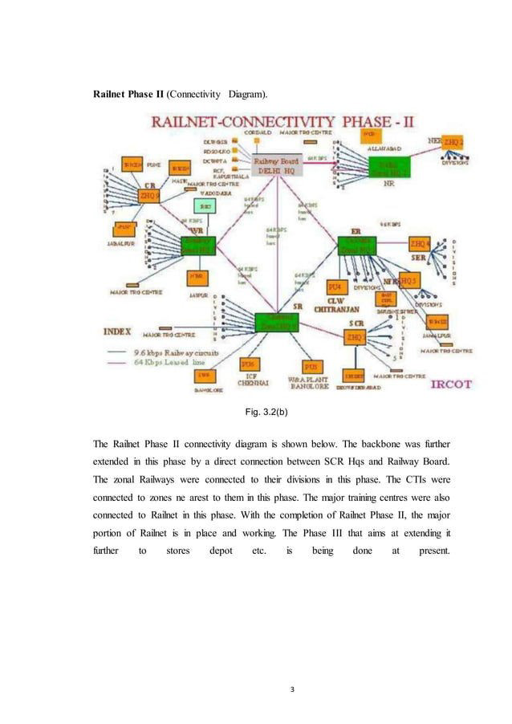

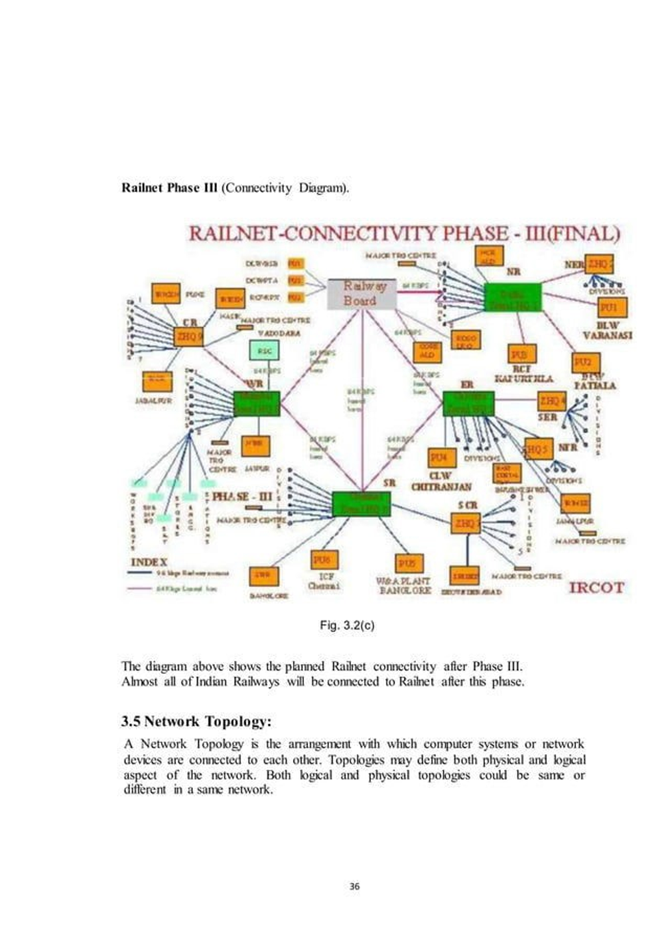

PASSENGER RESERVATION SYSTEM:

Indian railway is presently reserved and unreserved travel service to 23 million passenger a day on 13000 passenger trains through 7349 railway station.

When manual system was in vogue, reservation tickets were issued through the pigeon holes of the ticket and the details used to be recorded in the KARADEX register which contains the full details of the passenger, train number, seat/ berth number etc, and this KARADEX register forms the base for preparation of the chart. It is a fact that manual system was not transparent. To overcome this problem Passenger Reservation System (PRS) was introduced in 1984-85. Since then, number of upgradations and improvements was undergone by PRS system and today we can reserve the tickets through mobile apps.

UNRESERVED TICKETING SYSTEM:

More than 2 core rail passenger travel in unreserved coaches everyday and thus form the bulk of rail users. For this category of passenger’s railway have introduced the facility of computerized UNRESERVED TICKETING SYSTEM was initially provided at 10 railway stations of delhi area in the first stage as a pilot project on 15 August 2002. It has been extended in an integrated manner to most of the stations all over the country. UTS is the complete solution to provide computerized unreserve tickets to railway passengers from dedicated counter terminals, hand held terminals, smart card, automatic vending machines etc.

ROUTER:

A router is a layer-3 device that routes packets based on their logical addresses. A router normally interfaces LANs and WANs in the internet has a routing table that is used for making decisions about the route. The routing tables are normally dynamic and are updated using routing protocols.

Router is a device that forwards data packets between computer networks, creating overly internetwork. A router is connected two or more data lines from different networks. Routers perform the “traffic directing” function on the internet.

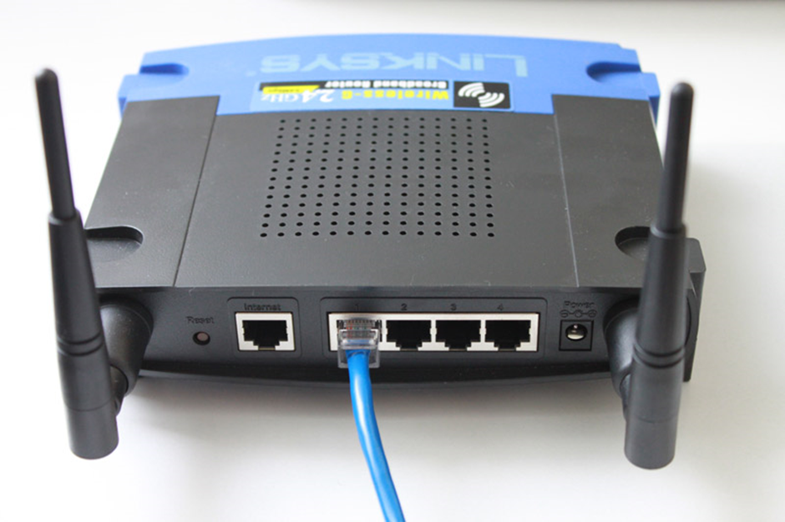

Fig 4.1 ROUTER

AUTO SIGNALLING/E.I :

The Electronics Interlocking (E.I.), which is based on software, is designed to prevent two trains from running on the same track at the same time. It ensures that a train gets a go-ahead only when the route ahead is clear. The system is an alternative to the conventional Relay Interlocking system.

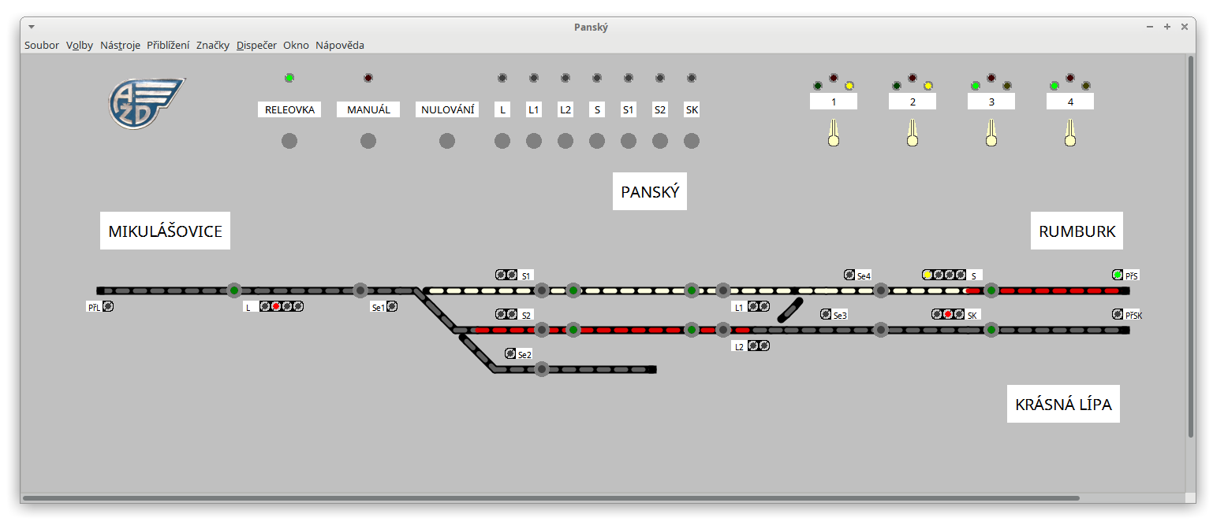

FIG. ELECRONICS INTERLOCKING

CONCLUSION :

Indian Railway, as an organisation is a very vast center of telecommunication itself. Today the telecommunicating world is getting its roots, grabbing the new era more firmly. We think that our training was success and Indian railways is an excellent train institute for emerging engineers.